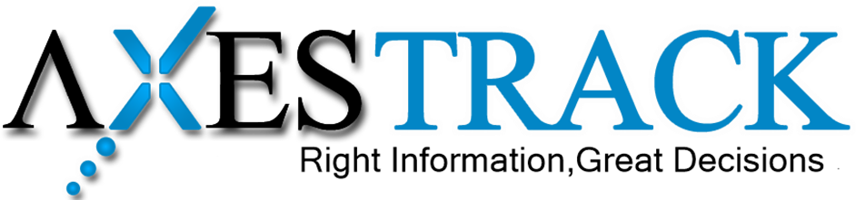





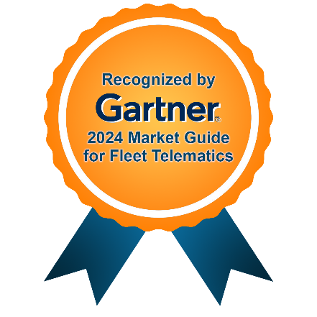

Proposal Document
for
ATUL Limited

Submitted on – November 1, 2025
Corporate HQ
Axestrack Software Solutions Pvt. Ltd.,
Office No.-19, 6th Floor, Jaipur Electronic Market, Near Riddhi Siddhi,
Gopalpura bypass, Jaipur – 302018, Rajasthan, India
Table of Contents
1. Respondent Information 2
1.1 Axestrack Overview 2
1.2 Axestrack Expertise & Recognitions 3
1.2.1 Recognized by analysts 3
1.2.2 Stability with scale 4
2 Proposed Solution 5
2.1 Reverse Logistics Based GPS and E-sealing Solutions 5
3 Inbound Logistics Process Flow 6
4 Overview of Unified Platform 7
4.1 Xsights Dashboard 7
4.2 AI Capabilities 7
4.3 Efficient Reverse Logistics 8
5 Pragmatic View of Product Roadmap & Innovations Planned 9

Respondent Information

Axestrack Overview
Axestrack stands as a pioneer in transforming the logistics industry with innovative solutions that redefine fleet management. With over 15 years of expertise and only Indian company ever to be recognized in Gartner’s 2024 Market Guide for Fleet Telematics Solutions, we are a trusted name for businesses seeking smarter, safer, and more efficient operations.
At the core of our offerings is the Axestrack Operating System (aOS), a next-generation AI platform designed to go beyond traditional tracking. Built on advanced analytics, intelligent automation, and real-time insights, aOS delivers comprehensive solutions to optimize fleet productivity, reduce TAT, providing end-to-end visibility and control for inbound, in-plant, outbound and port operations and improve operational efficiency. (For more about the platform please visit - https://www.axestrack.com/)
Axestrack is more than just a technology provider; we are a partner in driving innovation. Our solutions for inbound movement, in-plant automation, outbound movement, logistics platform and many more brings together real-time visibility, actionable insights, and intelligent control, enabling businesses to predict, prevent, and resolve challenges before they escalate.
Our impact is far-reaching, with aOS managing over 250,000 commercial vehicles globally, for 100+ clients and enabling smarter logistics across diverse industries like Cement, Metals & Minerals, Automobile, FMCG, E-commerce, Chemical, etc. Whether it’s fleet owners, consignors, plants, or port authorities, we deliver tailored solutions that drive efficiency and compliance.
Recognized globally and trusted locally, Axestrack is committed to shaping the future of logistics. We are investing in advanced telematics, IoT integrations, and cloud-based control towers to ensure our clients stay ahead in an ever-evolving landscape.
With Axestrack, every journey becomes smarter, safer, and future-ready.
Few of our successful customers / references.

Axestrack Expertise & Recognitions

Recognized by analysts
Axestrack has been widely recognized as a top digital solution provider through industry research, awards, and strategic partnerships. Axestrack has received numerous awards and accolades for its innovative digital solutions, including Gartner’s 2024 Market Guide for Fleet Telematics.
Axestrack believes in excellence which led our innovations and product capabilities recognized by multiple analysts and market leaders to solve transportation challenges in the industry.
According to Gartner ‘The fleet telematics market is growing, driven by the increasing demand for efficient fleet management solutions and operational optimization. This growth is catalyzed by widespread telematics adoption, supportive regulatory frameworks, reduced operational costs and enhanced customer satisfaction through real-time visibility on deliveries, driver safety and retention. The integration of AI, ML, and big data analytics is poised to propel the market forward by delivering advanced insights and predictive capabilities for fleet management.

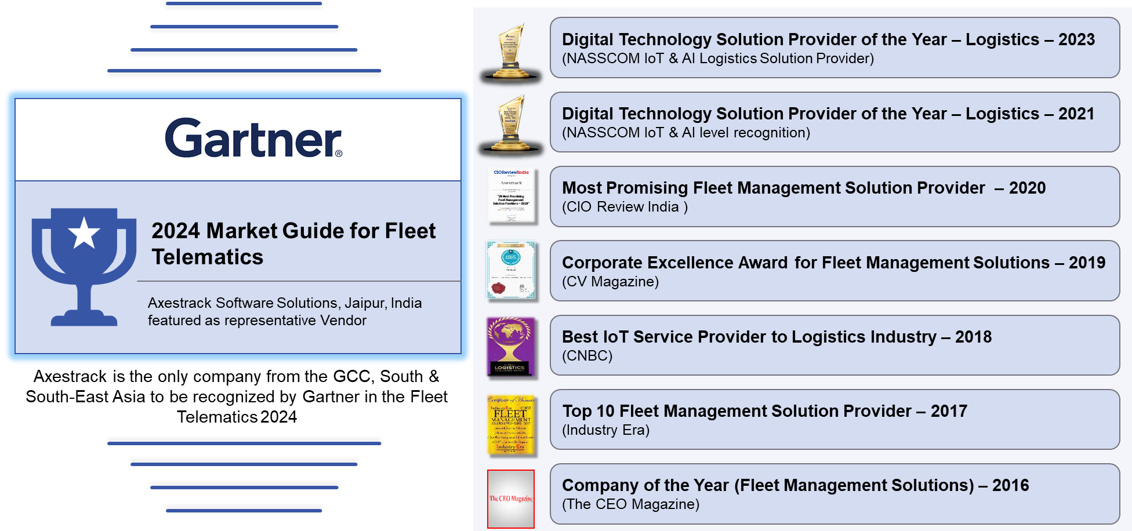

Stability with scale
At Axestrack, we are more than a solution provider—we are strategic partner. With over 15 years of experience in logistics and technology, and the management of our own fleet of 200+ vehicles, we leverage our deep industry expertise to proactively analyze key business KPIs and recommend targeted solutions that address operational gaps. As a bootstrapped and profitable organization, we currently manage 2.5 lakh+ fleets and oversee lakhs of trips monthly.
Our in-house Center of Excellence (CoE) designs, develops, and deploys cutting-edge digital solutions tailored to the logistics industry. These solutions support every stage from proof of concept (POC) to full implementation and enhancement. Our unified platform seamlessly integrates with any ERP system as a bolt-on solution, enabling faster, more efficient operations and driving impactful improvements across logistics processes.

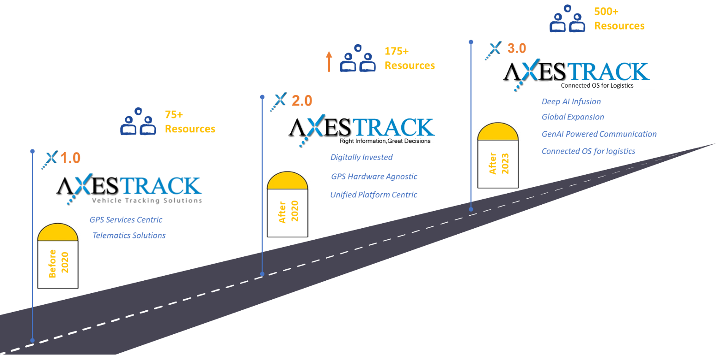

Business Requirements

Business Need and Why
ATUL Limited operates large-scale chemical manufacturing units in Valsad and Ankleshwar, dispatching finished goods to domestic depots and ports (Hazira & Nhava Sheva) through market fleet transporters. With over 50 trips daily managed by 21 transporters, the company requires real-time visibility, trip compliance, and accountability across its outbound operations.
Their existing SIM-based and API-based tracking methods have proven ineffective due to dependency on external fleets, lack of SIM consent, and inconsistent data availability. To maintain operational excellence, safety compliance, and on-time deliveries, ATUL needs a reliable GPS-based plug-and-play solution with integrated reverse logistics and ERP/TMS connectivity.

Problem Statement
• Inability to track market fleet vehicles due to SIM and API consent issues.
• Lack of unified trip visibility across multi-destination and port-bound routes.
• Manual coordination with transporters causing delays and higher turnaround time (TAT).
• Absence of structured reverse logistics leading to device loss and poor asset utilization.
• Non-standardized proof of delivery and safety compliance monitoring.
These challenges result in limited visibility, data gaps, non-compliance, and higher operational costs, directly impacting supply chain efficiency and delivery reliability.

Proposed Solution
ATUL Limited operates two manufacturing plants — Valsad and Ankleshwar being major chemical production hubs. Their logistics involve multi-destination and single-destination trips handled by 21 transporters, with outbound movements to Hazira and Nhava Sheva ports along with domestic depots.
Axestrack proposes a GPS-based Plug & Play Tracking Solution with integrated Reverse Logistics Management, ePOD, and MCT-based Safety Monitoring to provide ATUL full visibility, accountability, and compliance across its outbound operations.

Reverse Logistics Based GPS, ePOD and MCT Solutions
Key Features:
- Unified digital portal for real time tracking.
- Real time alerts on non-compliances enroute.
- Centralized Manage Control Tower (MCT) for proactive monitoring and exception management.
- ePOD (Electronic Proof of Delivery) for seamless trip closure and digital confirmation of deliveries
- Risk reports and advanced analytics
- Easy installation/uninstallation using plug and play devices.
- Streamlined reverse logistics.
- Advanced analytics using Xsights.
Value Impact:
- Enhanced Visibility
- Cost Optimization
- Enhanced delivery compliance with real-time proof of delivery.
- Streamlined operations with centralized MCT oversight.
- Informed Decision making and accountability

Scope of Service

Functional Scope
- Trip Management:
Creation, monitoring, and closure of single and multi-destination trips across ports and domestic depots.
- Real-Time Tracking:
Continuous GPS-based monitoring of all active vehicles through the XSwift Platform with live status, route progress, and TAT analytics.
- Exception Management:
Real-time alerts for deviations, stoppages, over speeding, and unauthorized route changes with escalation workflows.
- Electronic Proof of Delivery (ePOD):
Digital confirmation of deliveries with photo capture, timestamp, and consignee acknowledgment.
- Reverse Logistics Management:
Structured process for GPS device retrieval, testing, and redeployment — managed either by drivers or Axestrack.
- Safety & Compliance:
Integration with Driver Monitoring System (DMS) and ADAS to support ATUL’s safety initiatives and government compliance standards.
- MCT (Monitoring & Control Tower) Support:
Centralized monitoring and intervention by Axestrack’s MCT team for operational support and alert resolution.
- Integration & Reporting:
Automated data exchange with SAP ERP and FreightFox TMS for unified dashboards and performance reports.

Technical Scope
• Hardware:
Plug-and-play GPS devices compatible with multiple vehicle types; equipped for quick installation and removal.
• Platform:
XSwift, Axestrack’s unified logistics visibility and analytics platform, providing a secure, cloud-based interface for live monitoring, alerts, analytics, and reporting.
• Connectivity:
Real-time communication through GSM/GPRS with fallback to offline data buffering; data hosted on secure cloud infrastructure with high availability.
• Integration Framework:
RESTful API integration with SAP ERP and FreightFox TMS to enable real-time data synchronization, event updates, and trip status visibility.
• Data & Analytics:
Centralized data repository with AI-driven dashboards, TAT analysis, and predictive insights for performance optimization.
• Security & Compliance:
End-to-end data encryption, role-based access control, and compliance with IT security standards and ISO guidelines.
• Scalability:
Modular architecture allowing seamless addition of new transporters, routes, or devices without system downtime.

Logistics Process Flow
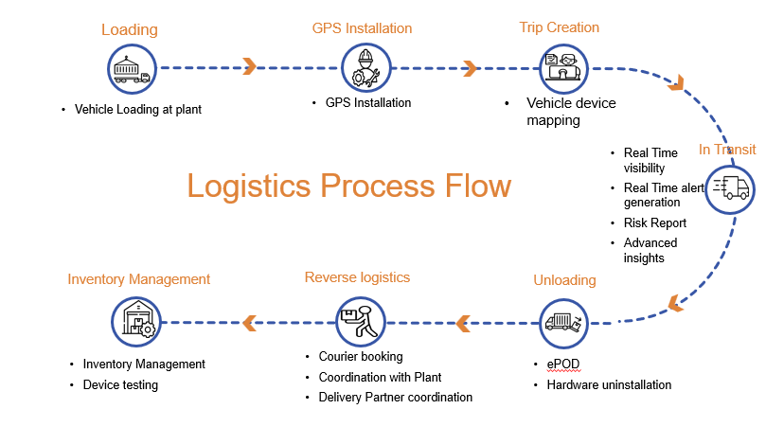

The Logistics Process Flow for ATUL Limited ensures secure and transparent movement of finished chemical products from plants to ports and domestic depots through Axestrack’s GPS-based Plug-and-Play solution integrated with the XSwift Platform.
The process begins with Loading, where goods are verified and loaded at the Valsad and Ankleshwar plants. In the GPS Installation Stage, a plug-and-play device is activated and mapped to the trip via the Axestrack app. Trip details including vehicle, driver, and route information are then created in the XSwift Platform, enabling live trip tracking and alert management.
During the In-Transit Phase, XSwift provides real-time visibility with alerts for route deviation, overspeeding, stoppages, and other exceptions. The Monitoring & Control Tower (MCT) team ensures safety and compliance by actively managing alerts and transporter coordination.
At the Destination, unloading and delivery are confirmed through ePOD, capturing photographic and digital proof. Post-delivery, the Reverse Logistics Process begins — GPS devices are retrieved either by trained drivers or managed directly by Axestrack. Returned devices undergo testing and inventory logging for redeployment in future trips.
This streamlined process ensures real-time visibility, safety compliance, and efficient device management, reducing operational delays and enhancing control across ATUL’s logistics network.

Overview of Unified Platform

Xsights Dashboard
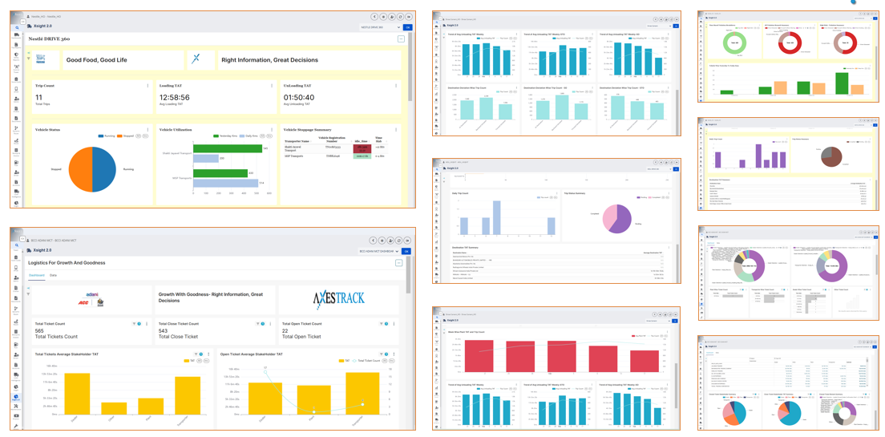

AI Capabilities

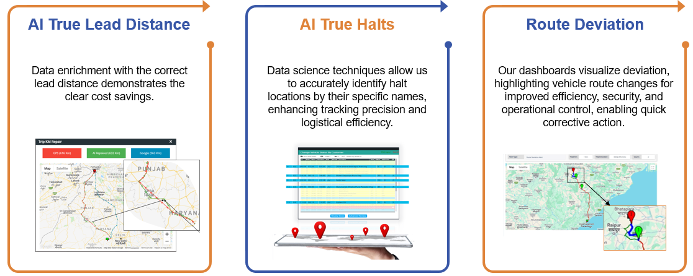

Efficient Reverse Logistics
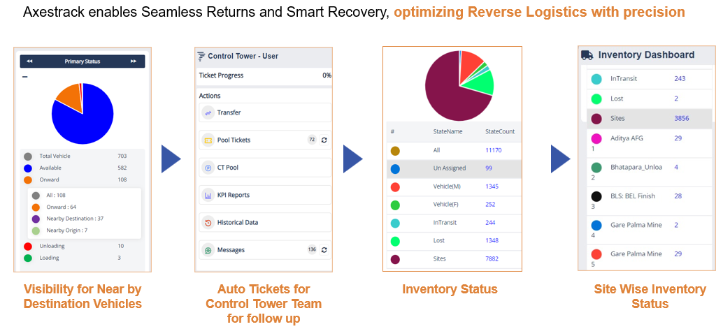

Pragmatic View of Product Roadmap & Innovations Planned
Axestrack’s product roadmap has been built keeping current and future needs of the industry in scope. The roadmap establishes our commitment to the innovations and capabilities which we co-develop with client to ensure these developments are relevant to the needs of the clients.
The intent behind this vision is simple. We understand that “connectivity” is the way for future and hence the core of any solution must embrace the connected part and should support the mechanisms which promotes connectivity.
We understand that while vision is clear, we also need to keep the structural elements flexible and modular. Hence, the design of our architecture and roadmap has been envisioned to be ‘modular and agile’.
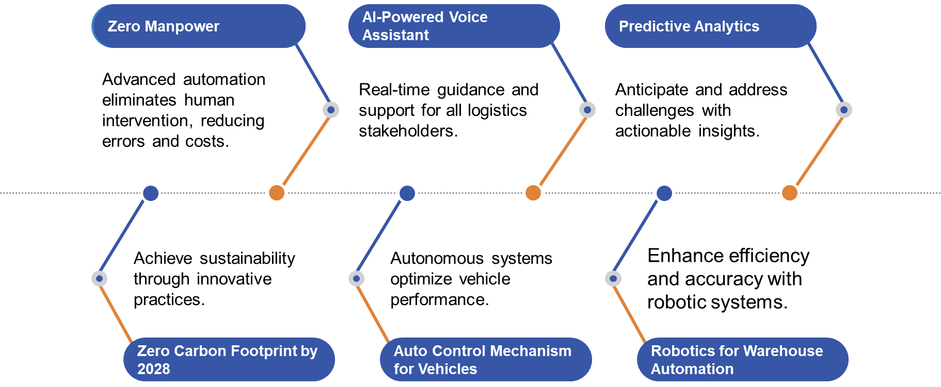


www.axestrack.com
www.

